**Steve Hagenlocher’s 2014 Volleyball Clinic 9-12th grade**

July 30-31 @ Canyon Lake High School

9:00am-12:00 & 1:00-4:00 - 2 days/2 sessions

Cost- $55.00 per athlete

Make checks payable to: Steve Hagenlocher

------------------------------------------------------------------------------------------------------------------------------------------------------------------------------------

**Don’t miss this opportunity to train with former NCAA Division 1 Coach Steve Hagenlocher**.

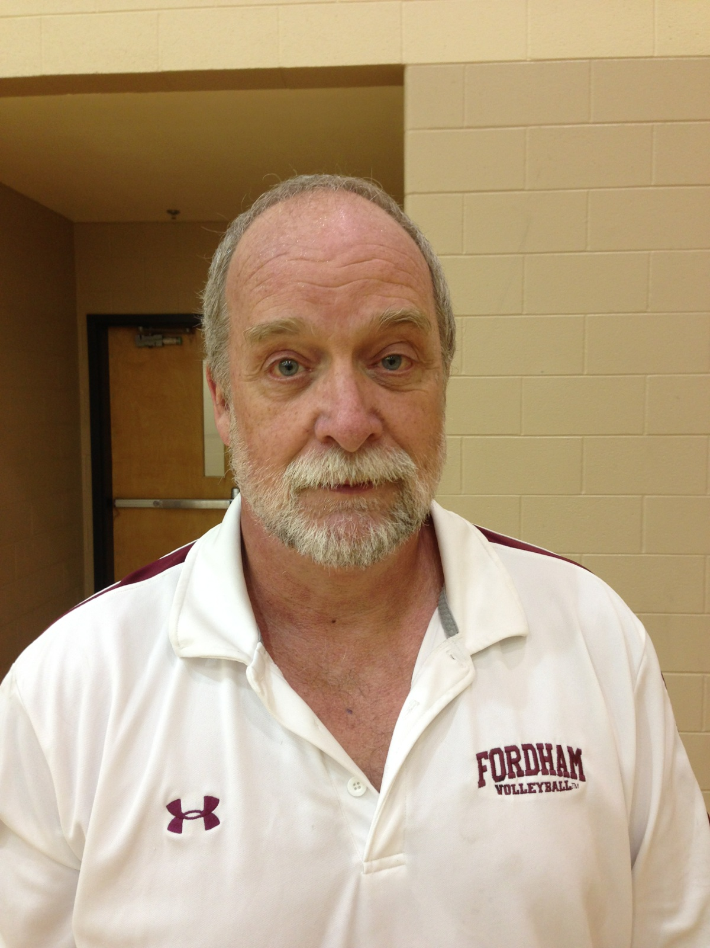Coach Hagenlocher has worked with athletes of all ages during his career and knows hundreds of drills

to grow your skills as you prepare for your next season!!! Try-outs will be right around the corner! Will you be ready?

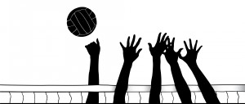**Coaching Experience:**

NCAA Division 1 - St Francis College Assistant Women’s Volleyball Coach 1995

NCAA Division 1 - St Francis College Head Women’s Volleyball Coach 1996-2000

NCAA Division 1 - Manhattan College Assistant Women’s Volleyball Coach 2001-2003

Metro Atlantic Athletic Conference Champions 2002, 2003

NCAA Division 1 Volleyball Championship Tournament 2002,2003

NCAA Division 1 - Fordham University Assistant Women’s Volleyball Coach 2004-2010

William C. Bryant High School Head Boy’s Volleyball Coach 1990-2013 New York City Champions 2005, 2011

Aviation High School Head Boy’s Basketball Coach 1990-2013

Townsend Harris High School Head Girl’s Volleyball Coach 2012-2013

NYC Jrs Volleyball Club Coach 1998-2006

------------------------------------------------------------------------------------------------------------------------------------------------------------------------------------

Release of Liability

I, and my heirs, in consideration of my participation in Steve Hagenlocher’s Volleyball Clinic, hereby release Steve Hagenlocher individually and Comal ISD and its affiliates/facilities, and any other people officially connected with this event, from any and all liability for damage to or loss of personal property, sickness or injury from whatever source, legal entanglements, imprisonment, death, or loss of money which might occur while participating in this event. I am aware of the risks of participation and I release said persons from any liability or responsibility for things including but not limited to the following: sprained muscles and ligaments, broken bones, fatigue or other unforeseen conditions. Furthermore, I hereby state that I am in sufficient physical condition to accept a rigorous level of physical activity. I understand participation is voluntary and I choose to participate. I understand that neither Comal ISD, nor Steve Hagenlocher provide medical coverage for me. I verify I will be responsible for any medical costs I incur as a result of my participation.

Athlete’s Name (Print): _______________________________________ Parent or Legal Guardian (Print): _____________________________________

Parent/Legal Guardian Signature: _______________________________ Date ________________________

(if under 18)